

Healthcare Organization Database

Course Name: Database Systems

Course: CSE301

Section: 01

Group No: 11

**Submitted By:**

Samia Islam 2018-1-60-040 40%

Md Jannatul Haq 2018-1-60-224 40%

Anika Hassan Mysha 2017-1-60-097 20%

**Submitted To:**

Md Mostofa Kamal Rasel

Assistant Professor,

Department of Computer Science and Engineering.

Submitted on**:** 09th January 2022

**Healthcare Organization Database**

**Project Description:**

In this project, we have made an application for the healthcare organization system. Healthcare management is a user-friendly web application system that is generally small or medium in size and this system is to automate day to day activity of a healthcare organization. It is basically used by healthcare centers to manage the healthcare-related records using the patient’s details, doctor’s details, nurse’s details, laboratory details, and so on. The project includes the features of a database that is adding, deleting, modifying, searching of required records that are designed and we have constructed an ER diagram by using ERDPlus. The search facilities provide a faster and easier way of viewing the records.

It uses different entities to provide the best service.

**Objective:**

Databases in healthcare sectors provide a proper system for storing, organizing, and managing critical health statistics such as labs, finances, billing and payments, patient identification, and more. This information must remain confidential to the public, but easily accessible for the healthcare professionals who use this data to save lives.

Databases in healthcare collect information about healthcare operations. Every piece of data a medical practitioner collects from a patient—including medications, prescriptions, procedures, operations data, and registries like encounter and discharge forms—is logged in a healthcare database. It’s almost impossible to imagine the sheer amount of healthcare data gathered daily.

Databases used in the healthcare industry can store loads of information and can assist with several tasks, including the most important healthcare mission of saving lives. Overall, along with supporting the daily operations of healthcare professionals, databases in healthcare can promote efficiency, information exchange, health quality assessment, and monitoring.

**Entity sets:**

In our project, we used a total of 5 entity sets. Entity sets are patient, doctor, nurse, laboratory, and reception. All of those are strong entity sets.

**Patient:** Patient keeps the information about the phone number, age, patient name, patient id, disease, and history.

**ER Diagram:**

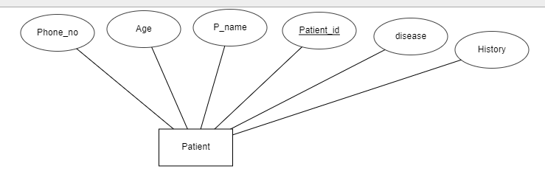

**Prepared by: Md Jannatul Haq**

**Doctor:** Doctor entity set keeps the information about the doctor name, degree, doctor id, designation, doctor schedule.

ER Diagram:

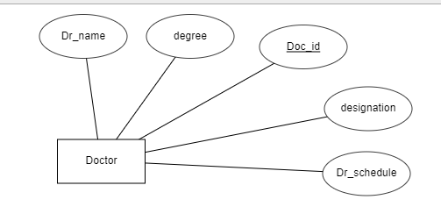

**Prepared by: Md Jannatul Haq**

**Nurse:** Nurse entity set keeps the information about the nurse name, nurse id, schedule.

**ER Diagram:**

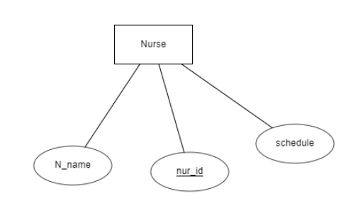

**Prepared by: Md Jannatul Haq**

**Laboratory:** Laboratory entity set keeps the information about the report information of patient and test sample.

**ER Diagram:**

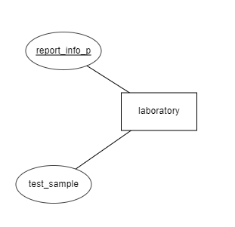

**Prepared by: Md Jannatul Haq**

**Reception:** The reception entity set keeps the information about the report information of bills, doctors information, schedule, and holidays.

**ER Diagram:**

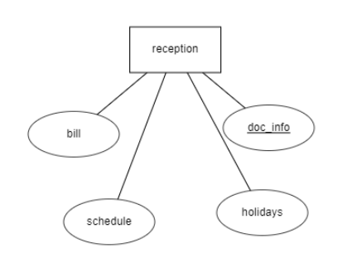

**Prepared by: Md Jannatul Haq**

**Cardinality constraints and participation:**

* **Patient – Doctor:**

Here, one patient can have many doctors and one doctor can have many patients. For this reason, this relation will be many to many relationships.

**Prepared by: Md. Jannatul Haq, Samia Islam**

**Patient – Laboratory:**

Here, one patient can use only one laboratory but one laboratory can be used for many patients. For this reason, the relation will be many to one relation.

**Prepared by: Md. Jannatul Haq, Samia Islam**

**Patient-Reception:**

Here, one patient can use only one reception but one reception can be used for many patients. For this reason, the relation will be many to one relation.

**Prepared by: Md. Jannatul Haq, Samia Islam**

**Laboratory-Reception:**

Here, one reception can use many laboratories but one laboratory can use only one reception. For this reason, the relation will be many to one relation.

**Prepared by: Md. Jannatul Haq, Samia Islam**

**Doctor-Reception:**

Here, one reception can use many doctors but one doctor can use only one reception. So, the relation will be many to one relation.

**Prepared by: Md. Jannatul Haq, Samia Islam**

**Doctor-Nurse:**

Here, one doctor can have many nurses and one nurse can have many doctors. So, the relation will be many to many relations.

**Prepared by: Md. Jannatul Haq, Samia Islam**

**Entity Relationship Table:**

|  |  |  |
| --- | --- | --- |
| **First Entity** | **Second Entity** | **Relation Type** |
| Patient | Doctor | n-n |
| Patient | Laboratory | n-1 |
| Patient | Reception | n-1 |
| Laboratory | Reception | n-1 |
| Doctor | Reception | n-1 |
| Doctor | Nurse | n-n |

**Prepared by: Md. Jannatul Haq, Samia Islam**

**ER Diagram:**

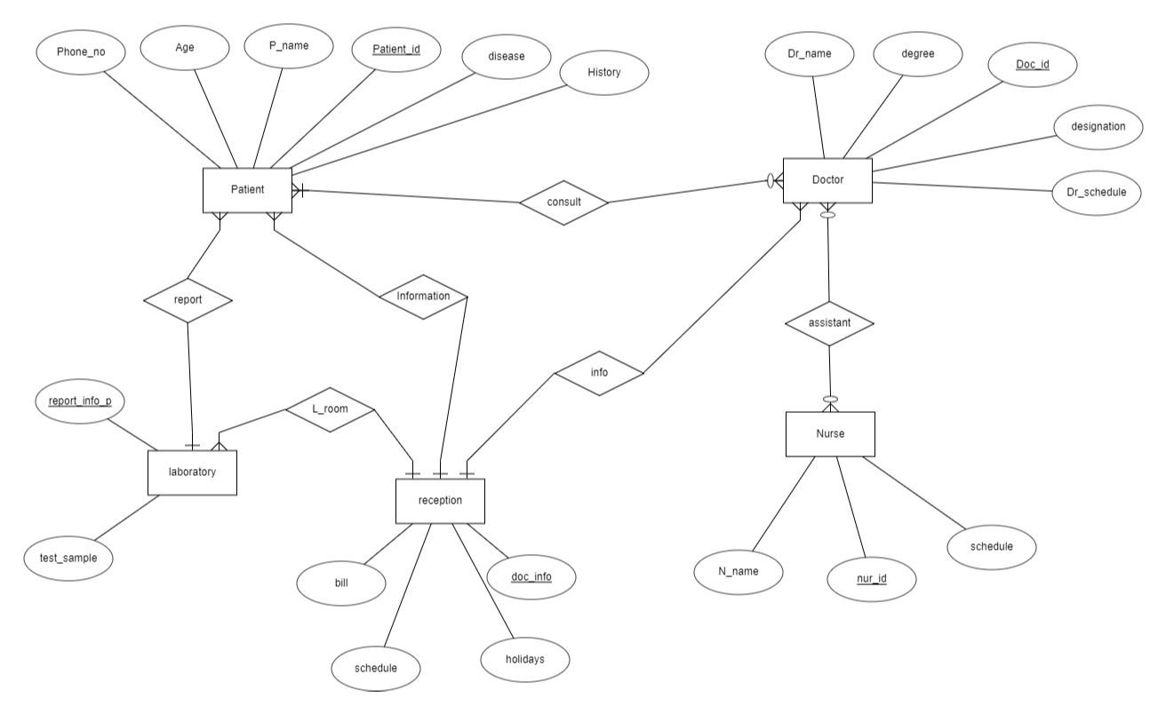

**Prepared by: Md. Jannatul Haq, Samia Islam, Anika Hassan Mysha**

**Relational Schema:**

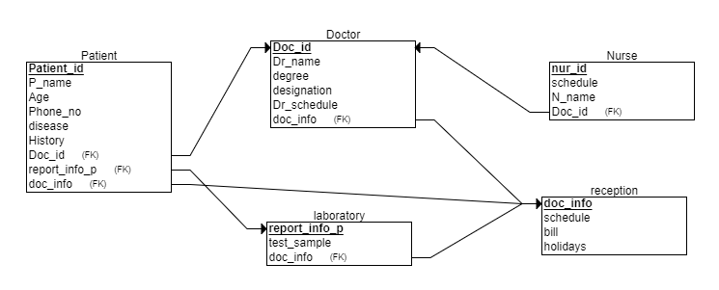

**Prepared by: Md. Jannatul Haq, Samia Islam, Anika Hassan Mysha**

**SQL Schema:**

An attachment has been provided.

**Prepared by: Md. Jannatul Haq, Samia Islam, Anika Hassan Mysha**

**Insertion of sample values:**

An attachment has been provided.

**Prepared by: Md. Jannatul Haq, Samia Islam, Anika Hassan Mysha**

**Join Queries:**

1. SELECT Dr_name, N_name, nur_id FROM doctor NATURAL JOIN nurse

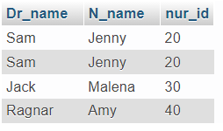

**Prepared by: Md. Jannatul Haq, Samia Islam, Anika Hassan Mysha**

1. SELECT Doc_id, Dr_name, bill FROM doctor NATURAL JOIN reception

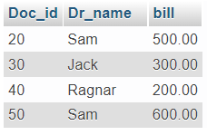

**Prepared by: Md. Jannatul Haq, Samia Islam, Anika Hassan Mysha**

1. SELECT doc_info, test_sample, report_info_p, bill FROM laboratory NATURAL JOIN reception

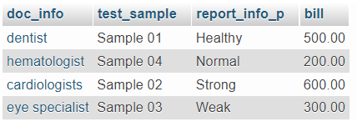

**Prepared by: Md. Jannatul Haq, Samia Islam, Anika Hassan Mysha**

1. SELECT P_name, Age, Dr_name FROM patient NATURAL JOIN doctor

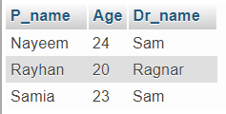

**Prepared by: Md. Jannatul Haq, Samia Islam, Anika Hassan Mysha**

1. SELECT Patient_id, Phone_no, test_sample, report_info_p FROM patient NATURAL JOIN laboratory

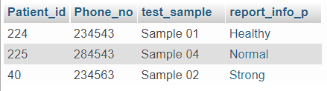

**Prepared by: Md. Jannatul Haq, Samia Islam, Anika Hassan Mysha**

1. SELECT * FROM doctor INNER JOIN nurse USING (doc_id)

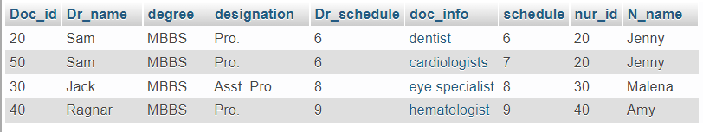

**Prepared by: Md. Jannatul Haq, Samia Islam, Anika Hassan Mysha**

**Update & Delete Queries:**

1. DELETE FROM patient WHERE patient.report_info_p IN (

SELECT report_info_p FROM laboratory WHERE

report_info_p='Weak')

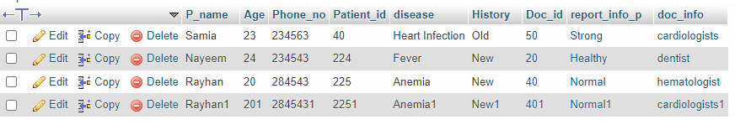

**Prepared by: Md. Jannatul Haq, Samia Islam**

1. UPDATE patient SET P_name ='x' WHERE age = 20

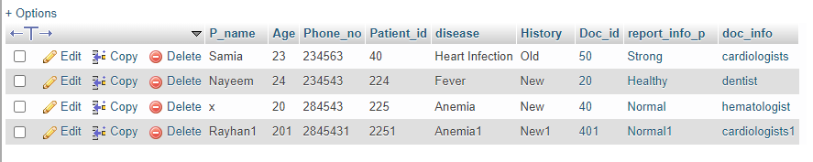

**Prepared by: Md. Jannatul Haq, Samia Islam**

1. UPDATE patient SET P_name ='y' WHERE Patient_id = 2251

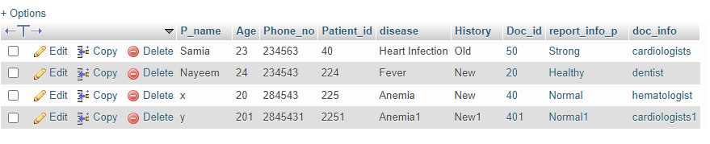

**Prepared by: Md. Jannatul Haq, Samia Islam**

**View and Materialized View:**

Here, in our project, there is not enough place to use view or materialized view, but if we want, we can make here the view of employee table.

CREATE VIEW view_Patient AS SELECT P_name,Age,Patient_id FROM patient

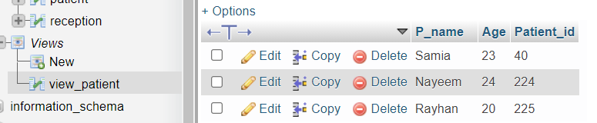

**Prepared by: Md. Jannatul Haq, Samia Islam, Anika Hassan Mysha**

**Conclusion:**

SQL database is the board application that is very much utilized in the advanced world in getting sorted out and controlling a database. Despite the fact that SQL doesn't have the GUI interface like Microsoft access is having and they all deal with the database agreeable. Contingent upon the client or clients, on the off chance that an association has different clients, at that point they should go for SQL worker-based application. This undertaking tells the best way to make tables in SQL and how to make basic information control language and information definition language with how to execute them. It likewise shows how connections are set up with the ideas of an essential and unfamiliar key inside a table. Finally, the undertaking shows how questions are made in SQL worker, inquiries like the make order, see, update, modify, and so on.